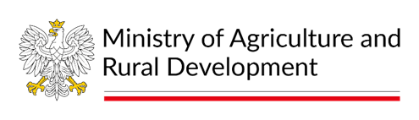

BALTFISH Forum Meeting
18th of June 2024, 12:00 - 17:00 CEST
Puro Hotel Gdańsk, Stągiewna 26 street and online via Teams
Agenda:
1. Opening of the meeting
2. Adoption of the agenda
3. Approval of the minutes from the Forum meeting on 5 September 2023
4. Update on the work program of the Polish BALTFISH Presidency
– presentation
5. Presentation of ICES advice for the Baltic Sea 2025
- presentation by National Marine Fisheries Research Institute and exchange of views
6. Evaluation of Compliance with the Landing Obligation Baltic Sea 2019 - 2021
– presentation by the Control Expert Group Chair
7. Bycatch mitigation measures for the Baltic Sea harbour porpoises (Baltic Proper & Belt Sea populations)
8. Update on Baltic Sea Advisory Council work and cooperation with BALTFISH
- presentation by the BSAC ExCom Chair
9. AOB
10. Closure

